INDIAN INSTITUTE OF TECHNOLOGY, KHARAGPUR
Department: Computer Science and Engineering

Spring Semester, 2008 Full Marks 60
Date 29.04.08 Time: 180 mnts.
Sub. Code: CS 60078 Subject: Complex Network Theory

Attempt as much as you can

1. Suppose the degree distribution of a network consisting 10000 nodes can be expressed as {860, 1500, 3630, 2380, 1090, 540} where 860 is the number of one degree nodes, 1500 is the number of 2 degree nodes and so on. So the maximum degree of the network is six. Now let the following two attacks are mounted on the network
A. Probability of removal of a node having degree k is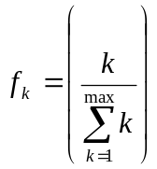
B. All the nodes having degree more than or equal to 4 are removed.

Check the stability of the network for both kinds of attacks. Assume that the network size is infinite. (5 + 5)

2.
. 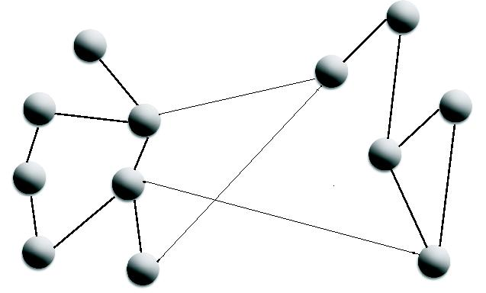
Fig. 1
A. Calculate the initial degree distribution (p_{k}) of the finite size network shown in Fig 1.

B. Now out of the total 12 nodes, 5 right side nodes are removed from the network and the seven left nodes survived.
1. Theoretically calculate (without using the Fig 1) the degree distribution (p_{k}’) of the survived network.
2. Calculate the degree distribution of the survived network (p_{k}’) using Fig 1.

[Your theoretically derived result (p_{k}’) may not match with the p_{k}’ derived from of Fig 1 due to the stochastic calculation in the theory.] (2 + 7)

3. Find the average component size of
  - Erdos Renyi graph (p_{k} = z^{k}e^{-z}/k!) (z is the average degree)
  - Scale free network (p_{k}=ck^{-α}) (c is the normalizing constant)
  - Network with exponential degree distribution (p_{k}=ce^{-k})
The formula for the average component size of a network can be given as
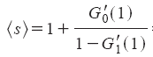
where G₀(x) and G₁(x) are different generating functions related to the degree distribution. Also assume that the network doesn’t contain any giant component.
d. Using the above formula find out the condition for giant component formation with respect to the degrees of the nodes in the network
(2 x 3 + 2)

4. a) Given p_{k}, the degree distribution of a bipartite network, derive the degree distribution of its corresponding unipartite network corresponding to the bottom nodes.
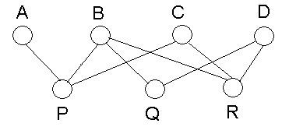
Fig. 2
b) Given the bipartite network in Fig. 2, draw its corresponding unipartite network (P,Q and R).

c) Given a unipartite network, propose an algorithm to generate the corresponding bipartite network. (3 + 2 + 1)

5. Suppose that I₀ = 25%, κ· = 0.4, α = 0.1 and γ =0.3.
a) Write the equations describing the SIS model with these parameters.
b) What is the steady state fraction of susceptible individuals?
c) What is the steady state fraction of infected individuals? (3 + 2 + 5)

Each infected person contacts γ non-infected people in each period and only α fraction of contacts result in an infection.1/ κ shows the time period of recovery.

6. (a) Define the clustering coefficient of order x of a node.
(b) Determine the clustering coefficient of order 1 to 5 of node i given in Fig. 3.

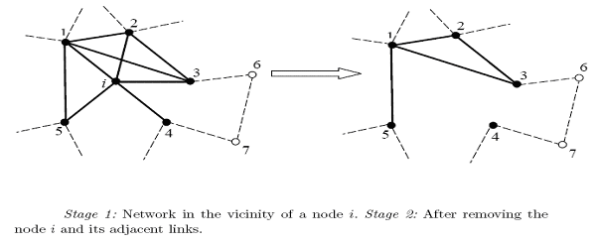
Fig. 3

c) State Newman’s model of small world network and from there determine the clustering coefficient of Newman’s model of small world network. (2 + 5 + 5)

7. a) Given the rate equation of the degree distribution N_{k} of an evolving network
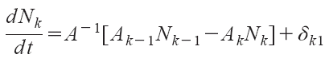
where A_{k} is the attachment rule (probability that an incoming node will establish a link with an existing node of degree k) and δ_{k1} is the Dirak Delta function at k=1. Normalizing function
Derive the first and second moment of the degree distribution N_{k}.

b) Given the situation that at each time step, a node joins the network with exactly m edges. The edges get joined preferentially with the existing nodes, that is, the probability of joining is proportional to the existing degree of the node. Write the discrete time Markov chain equation and from there derive the degree distribution of the evolving network. (hint : BA Network)

(5 + 5)

